(Approx. 1416 words)

Open-source Software
By Dick Maybach, Brookdale Computer User Group
www.bcug.com
n2nd (at) att.net

As its name implies, the defining characteristic of open-source software is that its source code is public, usually under a license that defines how it may be used. There are dozens of these licenses, but their terms are significant only If you distribute the software. Most allow you to charge for it, but you must use the same license you used to acquire it. So, for example, you could download the code for LibreOffice and sell it for $100, but anybody who bought it would be able to distribute it for free. Usually, you must also make the source code available if you sell an executable version, although some licenses don't require this. The concept is described in The Cathedral and the Bazaar by Eric S. Raymond, available at http://catb.org/~esr/writings/cathedral-bazaar/.

I included screenshots in this article to illustrate the variety of open-source software. Unfortunately, you won't find any text explaining the details.

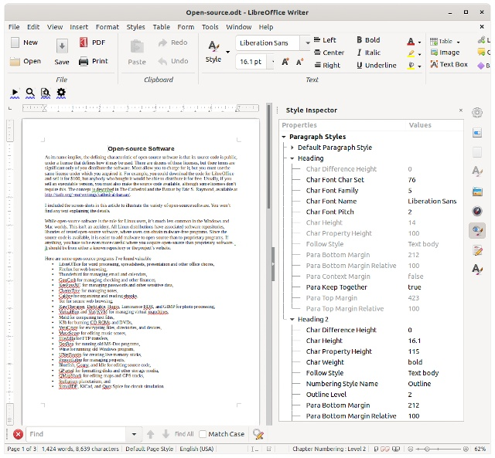

LibreOffice Write with the Style Tool in the (Normally Closed) Right Panel.

While open-source software is the rule for Linux, it's less common in the Windows and Mac worlds. This isn't an accident. All Linux distributions have associated software repositories, libraries of tested open-source software, where users can obtain malware-free programs. This is important because you have to be even more careful where you acquire open-source than with proprietary software. It should be from either a known repository or the project's website.

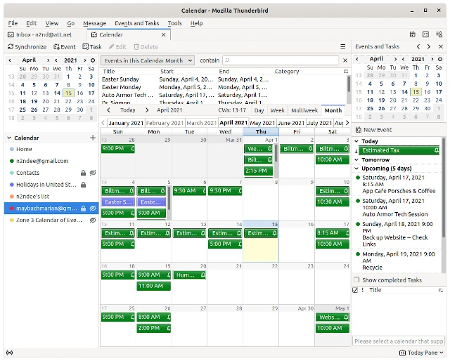

Thunderbird Email Client Showing Its Calendar Pane.

Here are some open-source programs I've found valuable

- LibreOffice for word processing, spreadsheets, presentation, and other office chores,
- Firefox for web browsing,
- Thunderbird for managing email and calendars,
- GnuCash for managing checking and other finances,
- KeePassXC for managing passwords and other sensitive data,
- CherryTree for managing notes,
- Calibre for organizing and reading ebooks,
- Tor for secure web browsing,
- RawTherapee, Darktable, Hugin, Luminance HDR, and GIMP for photo processing,
- VirtualBox and Virt/KVM for managing virtual machines,
- Meld for comparing text files,
- K3b for burning CD-ROMs and DVDs,
- VeraCrypt for encrypting files, directories, and devices,
- MuseScore for editing music scores,
- FileZilla for FTP transfers,
- DosBox for running old MS-Dos programs,
- Wine for running old Windows program,
- UNetBootin for creating live memory sticks,
- ProjectLibre for managing projects,
- Bluefish, Geany, and Idle for editing source code,
- GParted for formatting disks and other storage media,
- QMapShack for editing maps and GPS tracks,
- Stellarium planetarium, and
- SimulIDE, KiCad, and Qucs Spice for circuit simulation.

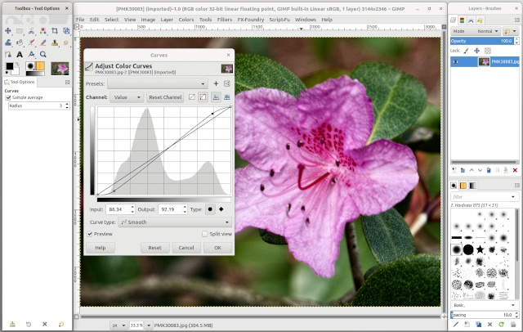

GIMP Photo Processor.

Open-source's big advantage is that it's free, which means you can try several programs to see which best fits your needs. The process can be complex; I considered a half-dozen accounting programs when moving from Quicken. This meant downloading and installing each and importing my Quicken data. I found two promising candidates and managed my accounts with both and Quicken for several months before deciding that GnuCash was the best fit. Few programs are worth this much effort, but you need to carefully choose something you use every day, such as office software, a web browser, a mail, and calendar program, or a password manager.

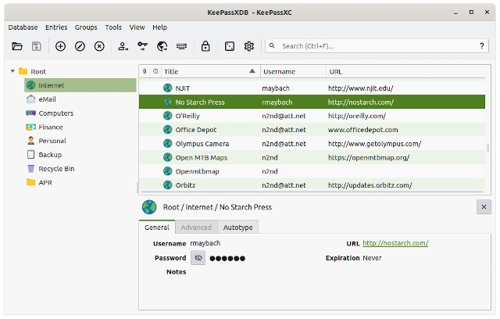

KeePassXC Secure Password Manager.

Of course, there is no free lunch, and while open-source software costs nothing in Dollars, it can cost more in time than a proprietary equivalent. For example, you will find tutorial books only for popular open-source programs such as Ubuntu and Python. Most do have manuals available on the project's website, and I usually consider using only those that do. However, I find that often the developers are well ahead of the tech writers. Furthermore, if the area is complex, such as photo editing, knowing what each control does may not be enough to produce attractive pictures. Therefore, I do a lot of Web surfing, looking for tutorial material, and in many cases adapt techniques used in commercial software for use in open-source ones. Finally, remember that "equivalent" is not the same as a "replacement." Equivalent programs perform similar tasks, but one can't necessarily replace the other, and you may have to revise the way you work to make a change.

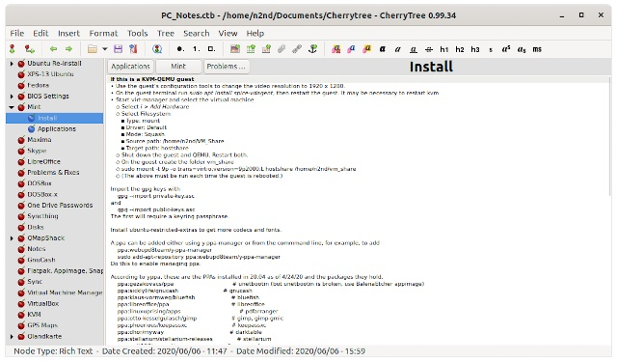

CherryTree Notes Manager.

Commercial programs often do more handholding than open-source ones. That is, they may have a single control for a task for which their open-source cousins have several. However, there are wide variations in both types, and you can probably find some open-source software that is easier to use than some commercial programs. Beginners may prefer simplicity, while those more experienced prefer better control. Also, commercial software more often combines several operations in a single program, meaning they may be able to replace several open-source ones. For example, in photography, I use RawTherapee or Darktable for raw development, Hugin for panoramas, Luminance HDR for high dynamic range work, and GIMP for retouching, while PhotoShop does it all. Choosing between a box of individual tools and a Swiss army knife is less important than finding which does the better job for you.

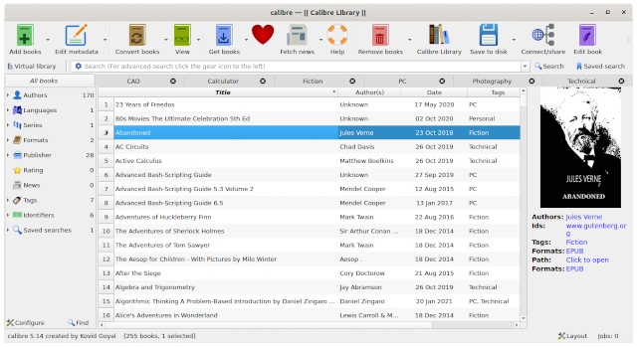

Calibre E-book and Document Manager, Editor, and Reader.

Open-source programs are more likely to use standard file formats. If a program stores its results using a proprietary format, especially one protected by a patent, you can lose information if it becomes unavailable.

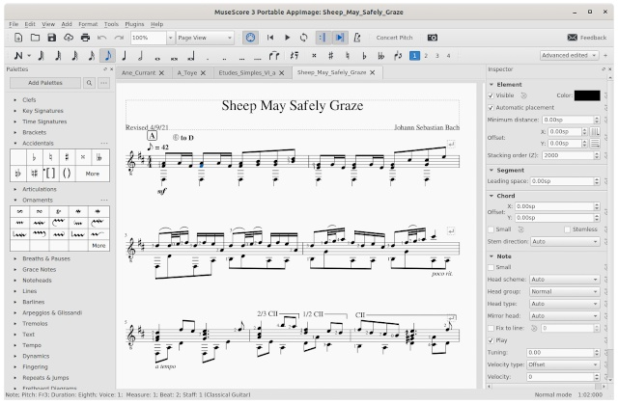

MuseScore Music Score Editor.

Open source is often touted as safer because its users can inspect its code, although there is a big difference between "can be" and "is." Security flaws are discovered in open-source software every few months, and some have been present for years. To be fair, if a vendor discovers a years-old flaw in a proprietary product, we most likely will never find out. However, that open-source code is available means you must be careful where you get your products. An evil developer could take the source code of a popular product, embed malware in it, and distribute it as the original. Most Linux distributions maintain repositories of verified safe applications, and many projects have their own well-known websites where you can also download with confidence. These sites often also publish checksums you can use to verify that the file you downloaded is the approved one.

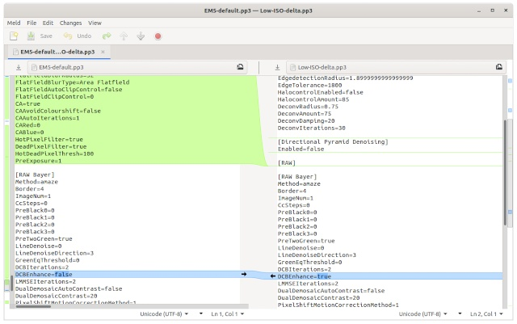

Meld Text File Comparison Tool.

You will often see the quote that "Open-source software is free as in speech, but not free as in beer." You can charge whatever you like for it, but you can't restrict what your customers do with it, including giving it away. As a result, you will find commercial services that distribute open-source software, which collect and distribute the products. That is, you pay for the DVDs or memory sticks and the costs of writing to them, but once you get them, their contents are yours to give away or sell. An example is PartedMagic, a live Linux distribution with a collection of open-source PC maintenance tools. Each tool is free, but you pay for the distributor to organize them into a kit. Many open-source licenses differ in what you can do with the code, but the terms are usually of interest only to businesses.

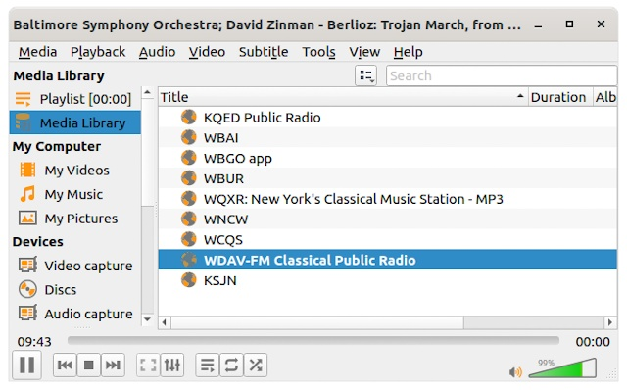

VLC Media Player.

Open-source software is easier to use on Linux, as tested, safe programs are available in the distribution's repositories. However, if you've used Windows or a Mac OS for many years, switching to Linux just to run a few open-source programs is needlessly traumatic. A better solution is to run Linux as a secondary operating system. I've found that the most convenient way to do this is on a virtual machine, which makes it just another application. (See my article in the August 2019 issue of Bytes, available at http://www.bcug.com/.) Most modern PCs have enough power to make this practical, provided they have at least 16 Gbytes of RAM. Thus, using Linux on a virtual machine not only makes open-source source applications more accessible but also isolates them from your primary operating system.

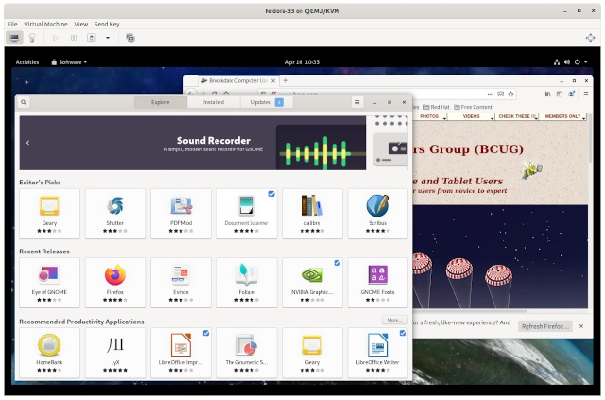

Fedora Linux Running on a Virtual Machine.

My early PCs used primarily proprietary software, MS-DOS and later Windows, MS Office, Quicken, and TurboTax. When a new version of a proprietary program became available, I often tried an open-source equivalent (or two or three) before I wrote a check. As a result, LibreOffice has replaced MS Office, GnuCash has replaced Quicken, Octave and Maxima have replaced MatLab and MathCad. Likewise, when I developed a new interest, I would usually look for open-source support software first. Would proprietary equivalents work better? Perhaps, but the free tools I use do everything I need, and I see no reason to spend money to look for replacements.

